Vocabulary Word | Definition | Example
Wide Area Network | A computer network in which the computers connected may be far apart, generally having a radius of half a mile or more. | 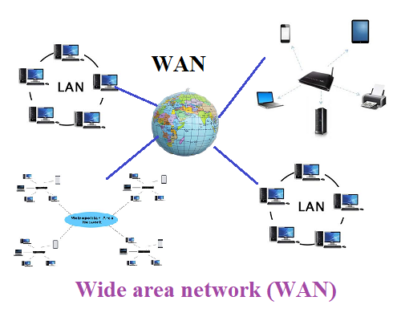
Host | The main computer in a network: controls or performs certain functions for other computers. | 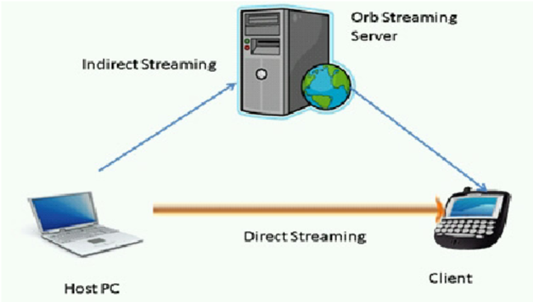
End Systems | An end system is a device that is connected directly to the Internet, creating an interface that individual users can access. End systems take numerous forms. They allow users to interact directly with the Internet to send and receive data and they may be used for everything from processing orders for a company to sending out photographs of a family vacation. | 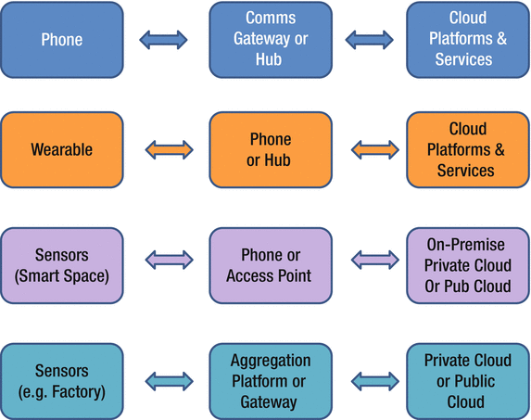
Bandwidth | In computing, bandwidth is the maximum rate of data transfer across a given path. Bandwidth may be characterized as network bandwidth, data bandwidth, or digital bandwidth | 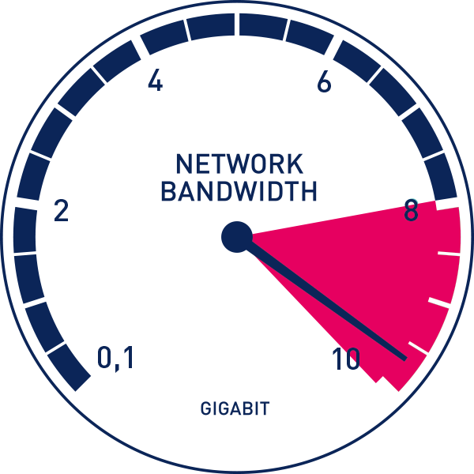
Bit Rate | In digital multimedia, bit rate refers to the number of bits used per second to represent a continuous medium such as audio or video after source coding (data compression). The encoding bit rate of a multimedia file is its size in bytes divided by the playback time of the recording (in seconds), multiplied by eight. | 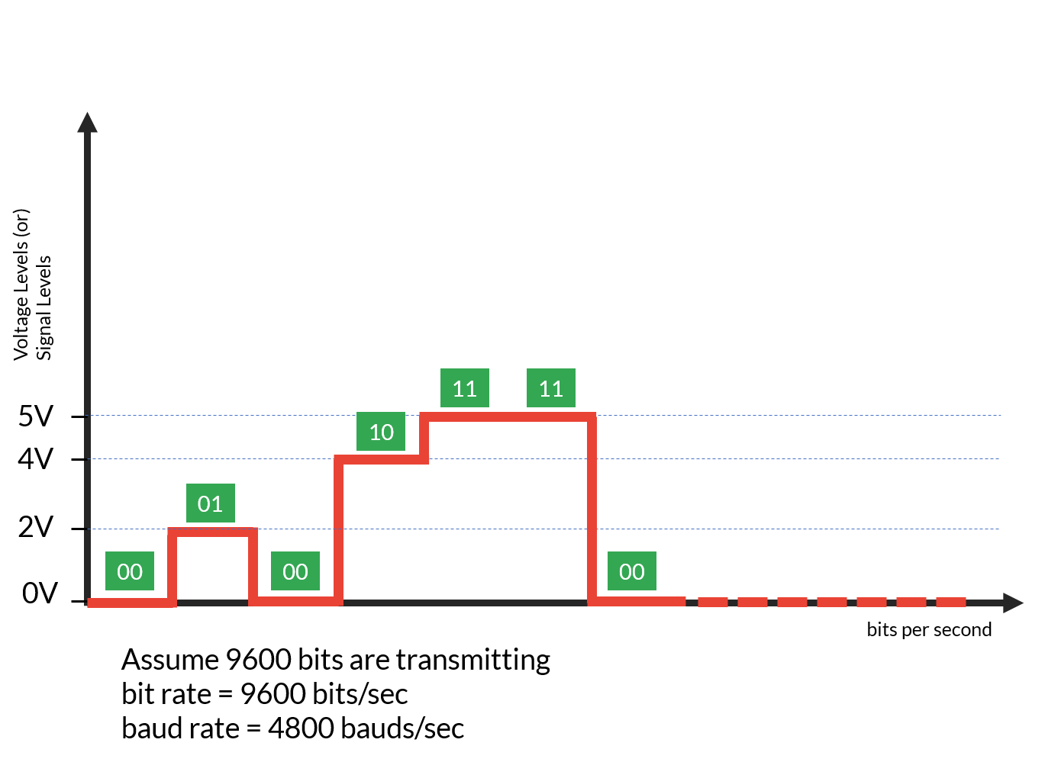
Route | In networking, routing is the process of moving a packet of data from source to destination. The principles of routing can apply to many networks such as circuit-switched networks and computer networks. Routing is typically performed by a specialized device known as a router. | 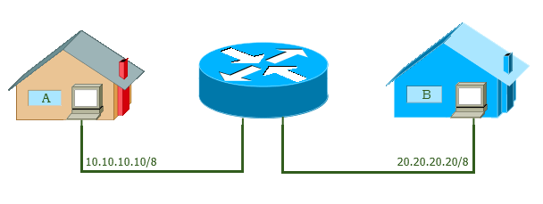
Path | A path is a string of characters used to uniquely identify a location in a directory structure. | 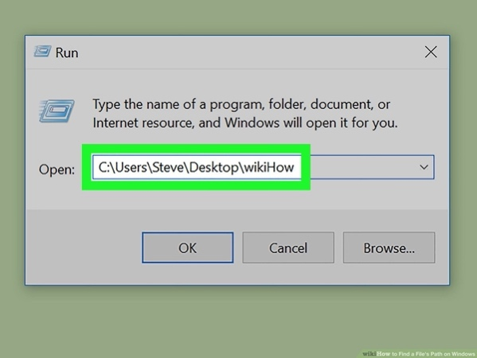
Edge Router | An edge platform, also called an edge router, is a single device for connecting and securing enterprise traffic to the cloud. | 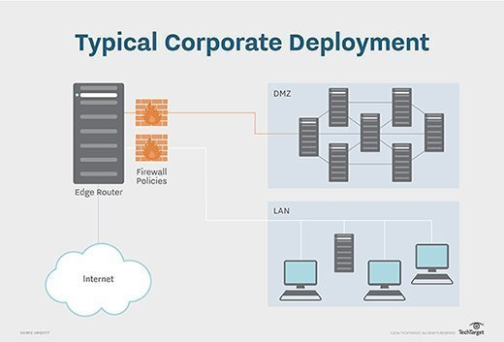
Clients | A client is a computer that connects to and uses the resources of a remote computer, or server. | 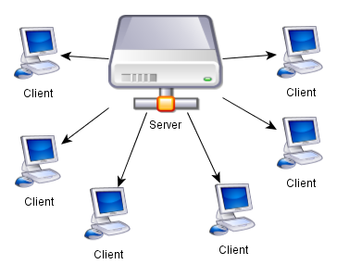
Servers | a computer or computer program which manages access to a centralized resource or service in a network. | 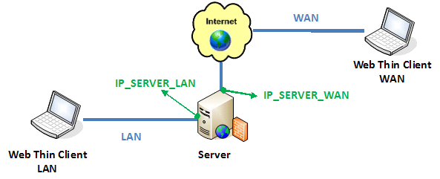
Digital Subscriber Line | Digital subscriber line (DSL; originally digital subscriber loop) is a family of technologies that are used to transmit digital data over telephone lines. | 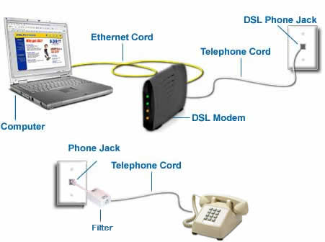
Internet Service Providers | a company that provides subscribers with access to the internet. | 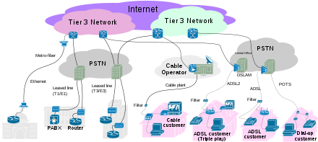
Protocols | A set of rules, for routing and addressing packets of data so that they can travel across networks and arrive at the correct destination.IP information is attached to each packet, and this information helps routers to send packets to the right place. | 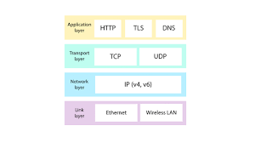
Wireless Network | a computer network that uses wireless data connections between network nodes. Examples of wireless networks include cell phone networks, wireless local area networks (WLANs), wireless sensor networks, satellite communication networks, and terrestrial microwave networks | 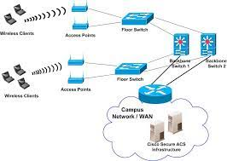
SMTP | The Simple Mail Transfer Protocol is an internet standard communication protocol for electronic mail transmission. Mail servers and other message transfer agents use SMTP to send and receive mail messages. | 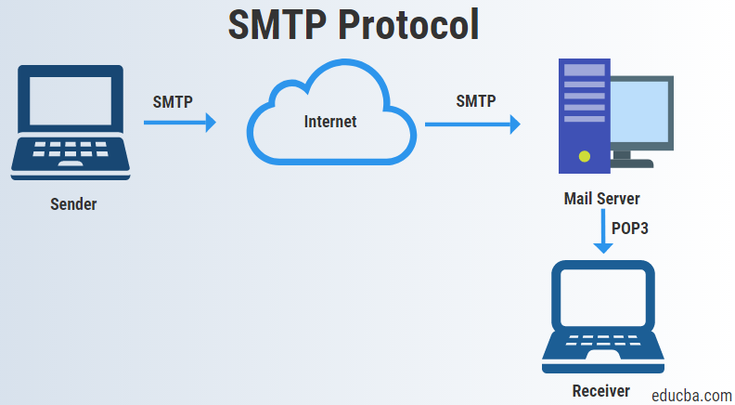
Local Area Network | a group of computers or other devices interconnected within a single, limited area, typically via Ethernet or Wi-Fi. | 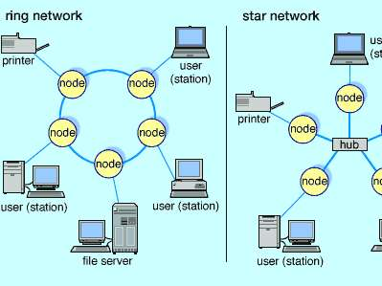
Distributed Applications | applications or software that runs on multiple computers within a network at the same time and can be stored on servers or with cloud computing | 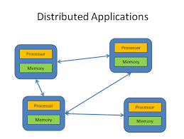
Application Programming Interface | is a connection between computers or between computer programs. It is a type of software interface, offering a service to other pieces of software. | 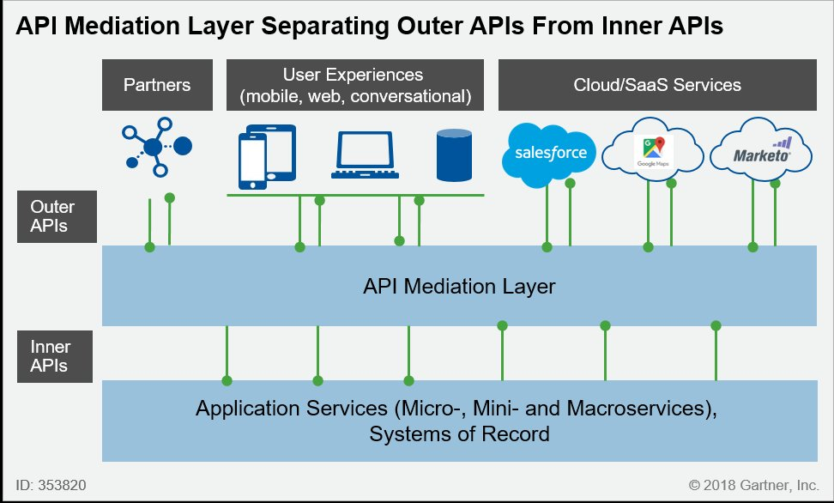
Services Description | With computer software, a service is software that performs automated tasks, responds to hardware events, or listens for data requests from other software. ... In a user's operating system, these services are often loaded automatically at startup, and run in the background, without user interaction | 